**23. Write a program to demonstrate HTML assertions in JMeter**.

It captures errors and warnings on the HTML page that jmeter connects to

After which it can put those errors and warning in a file and save it.

Create a Thread group 🡪 add sampler HTTP request

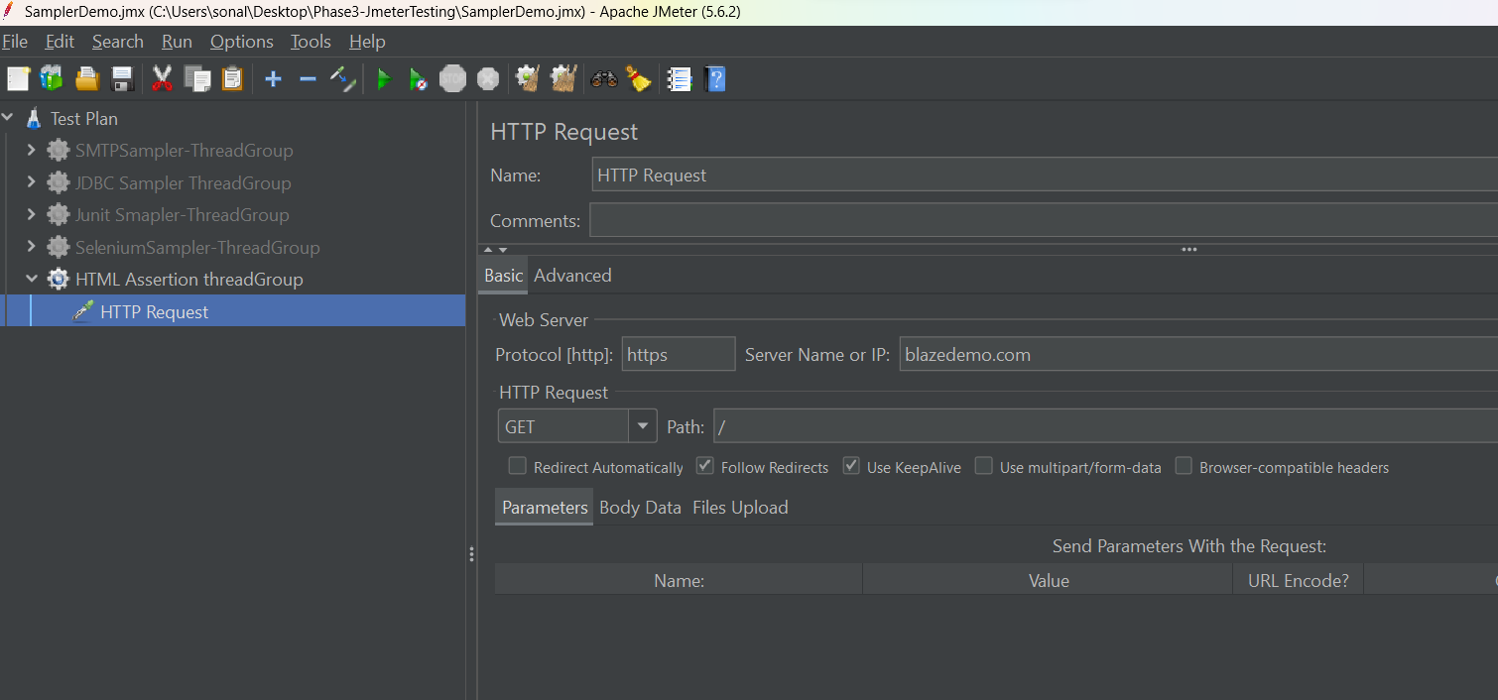

Add HTMl assertion to http sampler

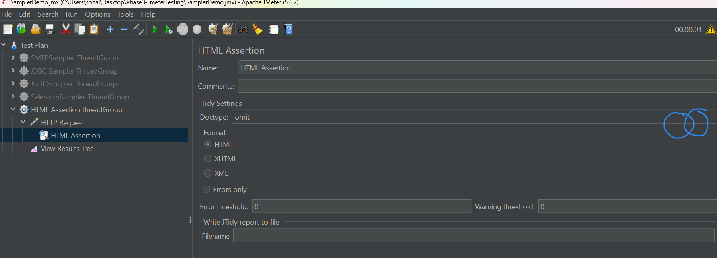

Create a new folder using browser button, also give the file name at the same time

